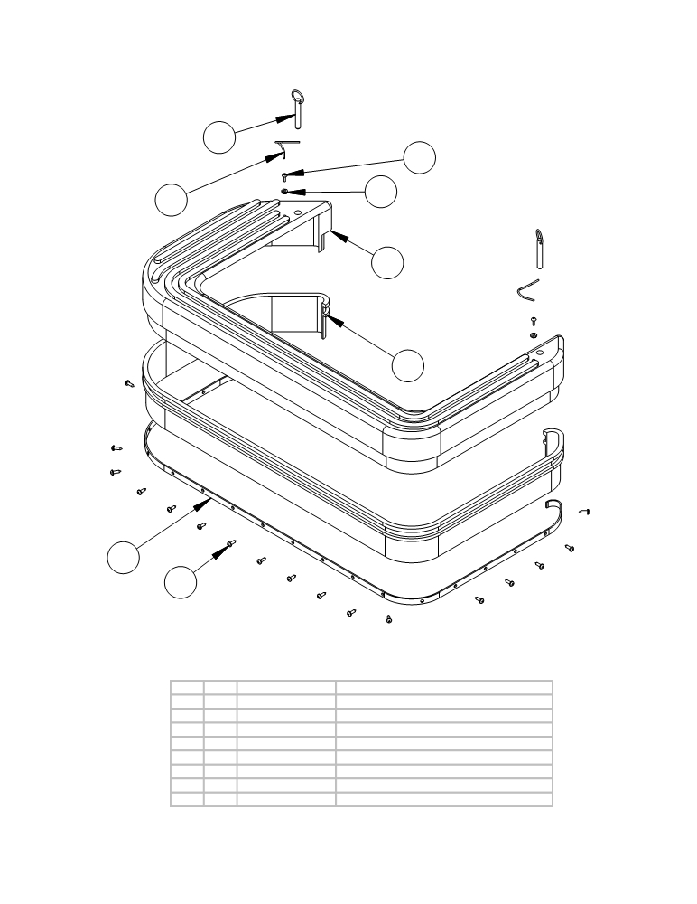
SPLASH SKIRT ASSEMBLY AND PARTS LIST

5
6

8

7

1

2

3

4

ITEM | SKU | DESCRIPTION | QTY
1 | E11232 | LARGE SKIRT | 1
2 | E11203 | Rubber splash skirt 76" | 1
3 | E10516 | SKIRT RETAINER FOR 32" | 2
4 | E11321 | #10 x 5/8 PAN HEAD PHILLIPS | 21
5 | E10774 | SINGLE BALL RING (1.5) GRIP | 2
6 | E11118 | 10-32 x .75 Unslotted Screw | 2
7 | E11095 | 10-24 NYLOC NUT | 2
8 | E87986 | Pin, Detent 5/16" OD x 3/4" L, Zinc | 2

ITEM QTY. PART NO. DESCRIPTION
1 1 AS26751 Plastic Skirt
2 1 AS261272 Rubber Splash Skirt
3 1 AS261131 Skirt retainer, for splash skirt
4 21 AS26/32257 Screw
5 2 AS26/32982 Detent Pin (single ball with grip ring)
6 2 AS26/32264 Screw
7 2 AS26/32242 Nyloc nut
8 2 AS26/32327 Lanyard for skirt detent pin

- 26 -

